Alexander Cannell

CSIS 6200

THE AMAZINGATOR VAM Model

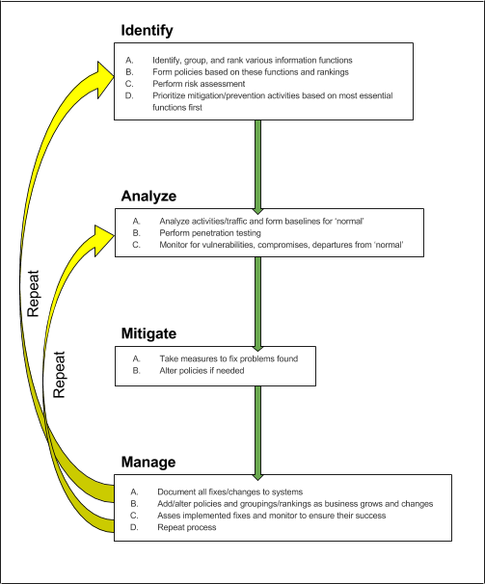

The only thing I would change from the group discussion is the repeat process in 4.d, I would add determine if Step one or step two needs to be repeated, if so repeat that step. I feel that needed further explanation.

1. **Identify**
   1. Identify, group, and rank various information functions
   2. Form policies based on these functions and rankings
   3. Perform risk assessment
   4. Prioritize mitigation/prevention activities based on most essential functions first
2. **Analyze**
   1. Analyze activities/traffic and form baselines for ‘normal’
   2. Perform penetration testing
   3. Monitor for vulnerabilities, compromises, departures from ‘normal’
3. **Mitigate**
   1. Take measures to fix problems found
   2. Alter policies if needed
4. **Manage**
   1. Document all fixes/changes to systems
   2. Add/alter policies and groupings/rankings as business grows and changes
   3. Asses implemented fixes and monitor to ensure their success
   4. Repeat processes: Determine if sub step c was a success. If not determine which step one or two needs to be repeated, and if so repeat the needed step.